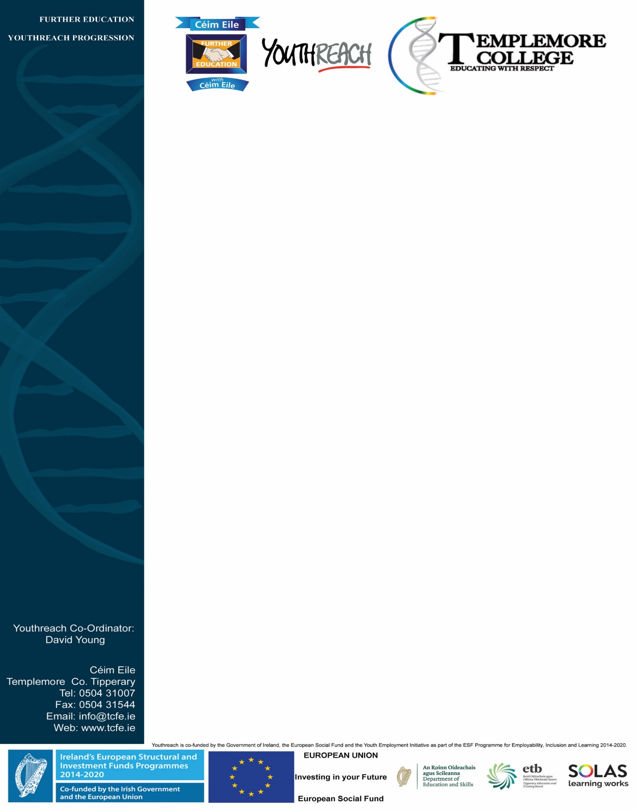

COVID-19 Policy Statement

Céim Eile is committed to providing a safe and healthy workplace for all our staff and a safe learning environment for all our learners. To ensure that, we have developed the following COVID-19 Response Plan. The BOM/ETB and all staff are responsible for the implementation of this plan and a combined effort will help contain the spread of the virus. We will:

o continue to monitor our COVID-19 response and amend this plan in consultation with our staff

o provide up to date information to our staff and learners on the Public Health advice issued by the HSE and Gov.ie

o display information on the signs and symptoms of COVID-19 and correct hand-washing techniques

o agree with staff as per protocol, a lead worker representative who is easily identifiable to carry out the role outlined in this plan

o inform all staff and learners of essential hygiene and respiratory etiquette and physical distancing requirements

o adapt the facility to facilitate physical distancing as appropriate in line with the public health guidance

o keep a contact log to help with contact tracing

o ensure staff and learners engage with the induction / familiarisation briefing

o implement the agreed procedures to be followed in the event of someone showing symptoms of COVID-19 while at the facilities

o provide instructions for staff and learners to follow if they develop signs and symptoms of COVID-19 during the time they are at the facilities

o implement cleaning in line with HSE and GOV.ie advice

All staff will be consulted on an ongoing basis and feedback is encouraged on any concerns, issues, or suggestions. This can be done through the Lead Worker Representative(s).

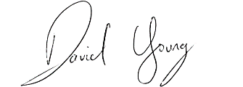

**Signed: Date: 20/08/2020**